Requirements Analysis Document
ATM System
CSCI 4711 Software Engineering
Fall 2014
Georgia Regents University
Augusta, GA
Date: 9/8/2014
Version 1

Team Members

Name 1
Name 2

Abstract

This document contains the requirements, analysis and design artifacts for the Automatic Teller Machine (ATM). ATM is an electronic computing device that will enable customers of the bank to perform financial transactions without the need for a human bank teller.
The customer will be identified via a unique pin number and account number. An authenticated customer is able to access their account information and perform various transactions including deposit, withdrawal, balance inquiry and change pin. An administrative user of the ATM is able to view a history of all customer transactions at the ATM. The administrative user is also identified via a unique pin number.
This document describes the requirements, analysis and design of the ATM system. The rest of this document is structured as follows. Chapter 1 contains the introduction. This chapter presents a brief description of the system. Chapter 2 outlines the functional requirements of the system.
Table of Contents

1 | INTRODUCTION……………………………………………............. |  |  | 4
 | 1.1 | OVERVIEW OF SYSTEM…………………………………………... | 4
 | 1.2 | SCOPE OF SYSTEM………………………………………………… | 4
 | 1.3 | OVERVIEW OF DOCUMENT……………………………………… | 4
2 | REQUIREMENTS OF SYSTEM……………………………………. |  |  | 5
 | 2.1 | FUNCTIONAL REQUIREMENTS………………………………….. | 5
 | 2.2 | USE CASES………………………………………………………….. | 6
 | 2.3 | USE CASE DESCRIPTIONS………………………………………… | 7

Introduction

Overview of System
ATM is a computing system for financial account management. It includes actors such as Customer who represent account holders of the financial institution, and Admin, the administrative employee of the financial institution who can view the history of all transactions at the ATM. The system supports both actors by keeping track account information and financial transactions. It also has access to a database of customer financial accounts. The Customer and the Admin actors interact with the ATM system through its user terminal.

Scope of system
The system includes functionality for verifying the customer, as well as account management activities such as making deposits, withdrawals, and balance inquiries from the customer. Administrative users can view transaction histories for all users of the system. All data stores are internal and part of system. The system is stand-alone, external interaction is solely with customers and administrative users.

overview of document
The rest of this document is structured as follows. Chapter 2 outlines the functional requirements of the system. Within this chapter is a list of functional requirements of ATM. It also includes a use case model of those functional requirements. A detailed description of each functional requirement then follows.

requirements of system

Functional Requirements
- VerifyUser – All users of the system have to be verified as either a customer or an employee of the bank before they can use the ATM. This function verifies the user and grants them access to other functionality.
- Deposit – Customers of the bank can add money to their own account via this function. The customer will specify a certain amount to be added to the account balance.
- Withdrawal – This function lets customers of the bank withdraw money from their own account. The customer will specify a certain amount to be withdrawn from the account.
- BalanceInquiry – This function enables the customer to view the balance of their own account.
- ViewTransactions – This function is used by an employee of the bank to view all the transactions and records of usage of the ATM system.

use cases

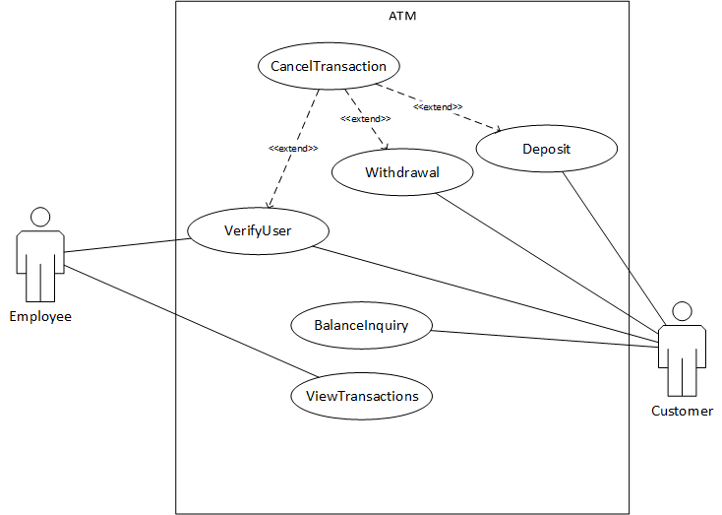
Figure 1: use case diagram for ATM

use case descriptions
Use case name | VerifyUser
Participating  actors | Initiated by Employee and Customer
Flow of events | - The “VerifyUser” function is activated when a valid credit or debit card is inserted into the card reader.  - ATM responds by presenting a login screen to the user. The login screen contains a field for the PIN number.  - The user fills out the form by entering their PIN number. Once the form is completed, the user submits the form. If the user selects the cancel button, the “CancelTransaction” use case is activated.  - ATM receives the form and verifies that the PIN is correct. If the PIN is incorrect, the login screen is displayed with an error message. For valid users, the Main screen is displayed.
Entry condition | - A valid credit or debit card is inserted.
Exit condition | - The Main screen is displayed for the user.
Quality  requirements | - The PIN number should not be displayed as number during entry.

START EACH USE CASE DESCRIPTION ON A NEW PAGE

Use case name | CancelTransaction
Participating  actors | Initiated by Employee and Customer
Flow of events | - This function is activated when a user selects the cancel button on the Login screen, Withdraw screen or the Deposit screen (from the VerifyUser, Withdraw, and Deposit use cases respectively).  - The system stores persistently, information about the canceled transaction, the user, the current date and time. The system will display the Welcome screen.
Entry condition
Exit condition | - The Welcome screen is displayed to the user.
Quality
requirements

